**SOCIAL DISTANCING DEVICE**

**INTRODUCTION:**

With the significant increase in the cases of COVID-19, social distancing has become very important. Social and physical distancing measures aim to slow the spread of disease by stopping chains of transmission of COVID-19 and preventing new once from appearing. Even though the government has made the rule to follow social distancing, many people forgets to follow the rule. Especially in shops, Banks, ATMs and other places where people have to move in a queue. To tackle this situation, the social distancing remainder system can be used to maintain distance between each other.

**SOCIAL DISTANCING REMINDER DEVICE:**

This device is used to remind the user of the social distancing by turning on the buzzer and produce vibration when the distance between the user and other person is less than 1 meter. This device works only when the distance between the user and the other person is lesser then 1 meter. If the distance is higher than 1 Meter, the device automatically turns off.

This device simply uses an ultrasonic sensor to detect the space between the user and the other person by sending ultrasonic waves. The ultrasonic pulse is transmitted and received after hitting the other person. The received pulse is sent to a microcontroller and process the data and calculate the distance. If the distance is lesser than 1 meter, the microcontroller sends the information to sound the buzzer and produce vibration. And if the distance is greater than 1 meter, the device stays in the off state.

**WORKING:**

This project uses an ultrasonic sensor which transmits a high frequency sound pulse and then calculates the time to receive the signals of the sound echo to reflect back. The sensor has 2 circuits, one acts as a transmitter which transmits the waves and the other one acts as a receiver which receives the echoed pulse. Arduino NANO is used as the microcontroller, which process the received signal and determines whether the person is closer or not and sends a signal to the buzzer and the vibrator motor which produces the sound and vibration. The sensor is calibrated according to the speed of the sound in air. Using the time difference between the transmission pulse and the received sound pulse, the distance between the user and the other person can be determined. When the received pulse is higher which indicates the person is close and have to maintain social distancing. and when the received pulse is low, then the person is far.

**CIRCUIT DIAGRAM:**

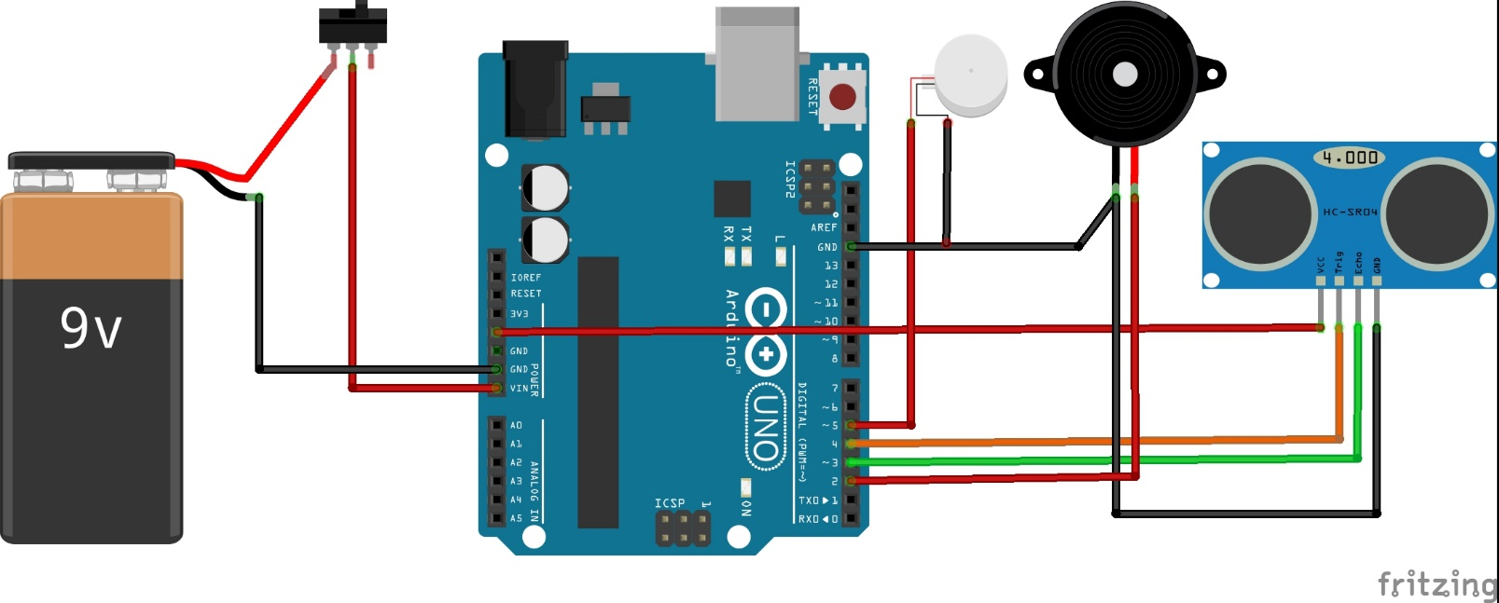

**PROJECT IMAGES:**

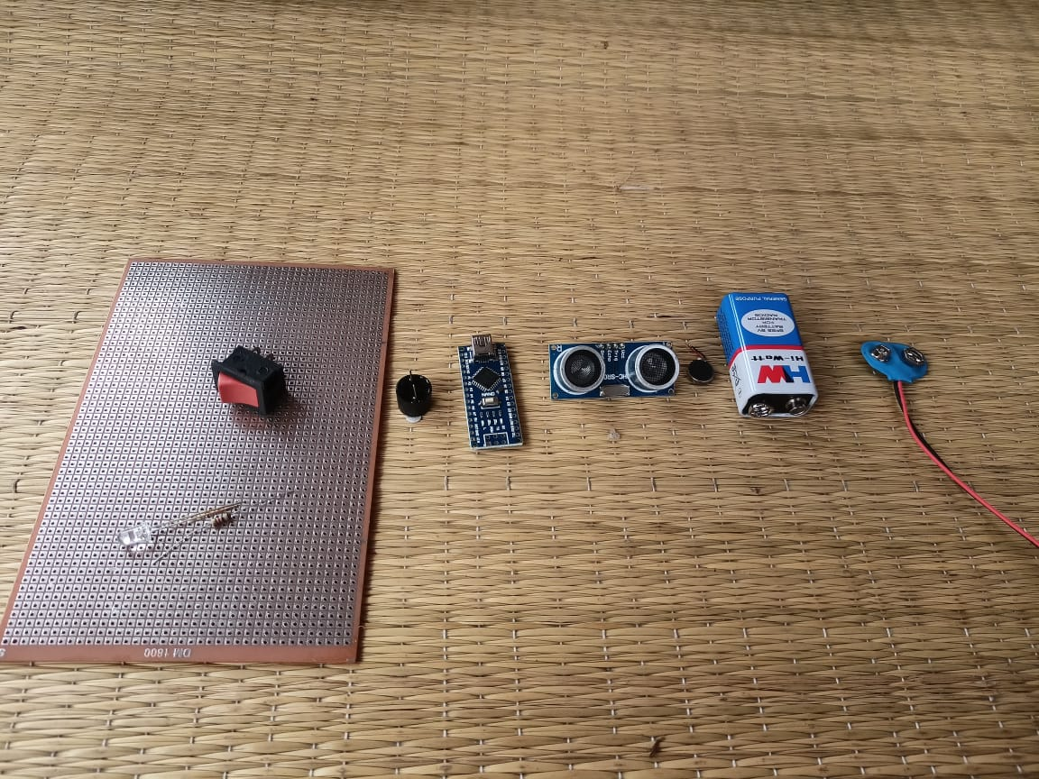

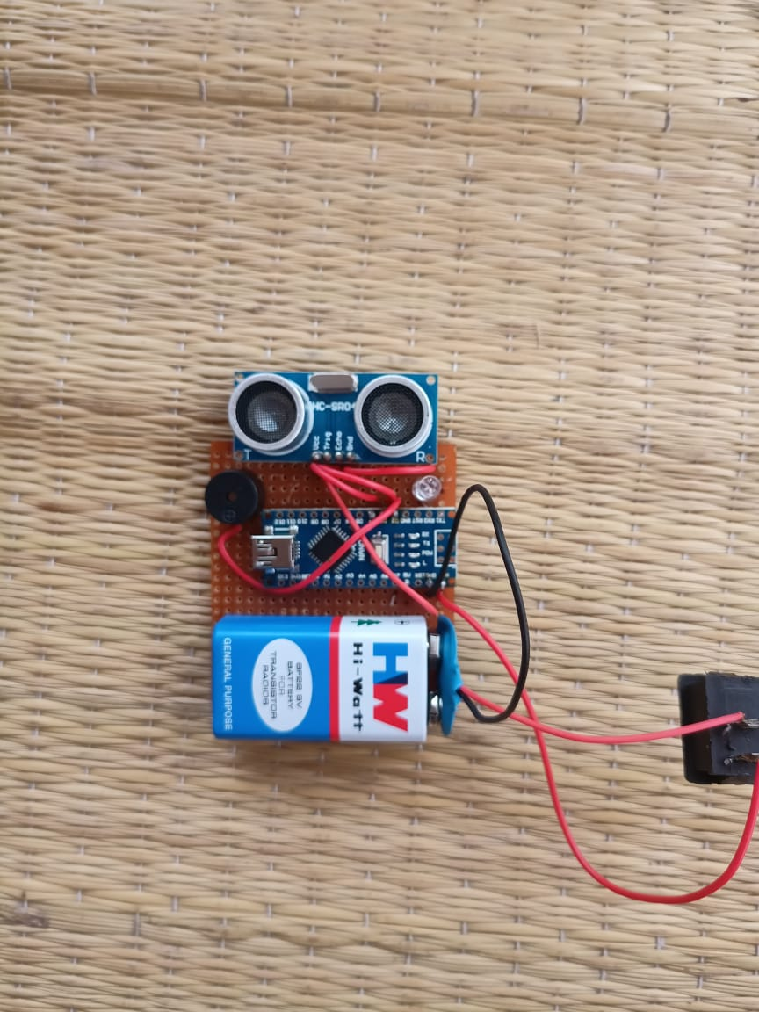

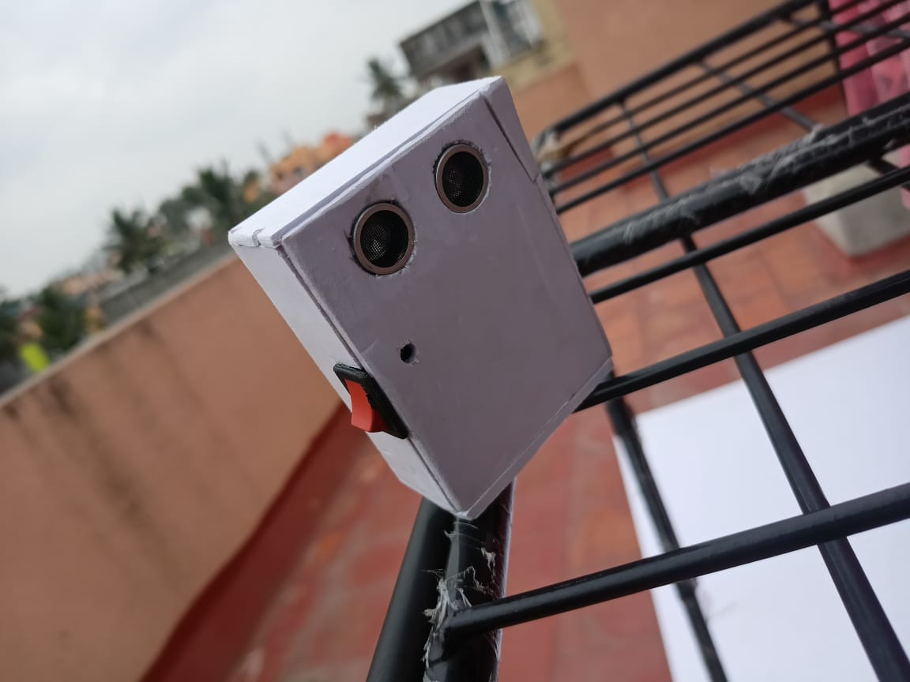

**RESULT:**

This project makes social distancing easier by remining people if they didn’t follow social distancing. When using this device, whenever the user gets close to someone, the buzzer will turn ON to remind you about the distancing. In this way, you can help yourself to tackle the Covid-19 epidemic. This project is easy to make and very useful to maintain your safety.